SRS Document

Our project is to create a class scheduling application using Java, SQL, and PHPMyAdmin.

Project Goals/Main Functionality:

- Add class

Students can add classes into their schedules.

-Drop class

Students can drop a class from the schedule

-View Schedule

Students will be able to see their schedule similar to how it appears on MyRIC

- Pre-requisite courses met

The application will use logic to make sure that students have taken required prerequisite classes.

-Dates and Times

Dates and Times of course will be visible to student

- Handle Scheduling Conflicts

Program will handle students who make conflicting schedule additions.

Extra add Ons (If time allows)

- Credits

Students will have a credit count and each course will have credits just like RIC

- Built in advisor

Recommended classes will appear for major requirements.

Class Diagram

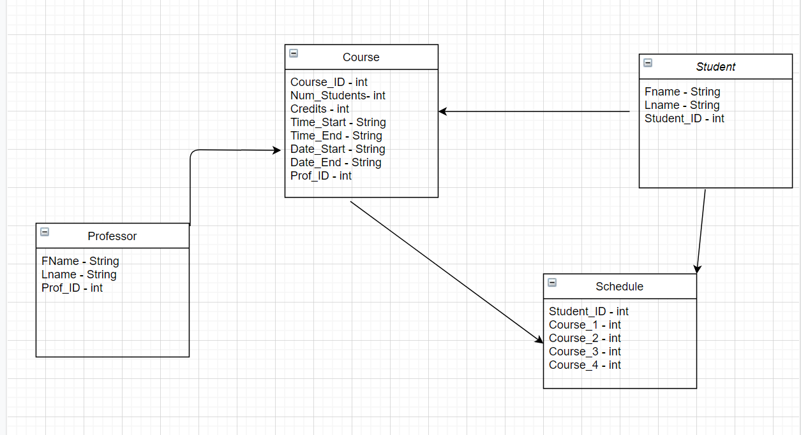

Four Main Classes

Student -

* Fname || Stores students first name
* Lname || Stores students last name
* Student_ID || Primary Key -Stores the students unique ID Number

Professor -

* Fname || Stores professors first name
* Lname || Stores professors last name
* Prof_ID || Primary Key - Stores the professors unique ID Number

Course -

* Course_ID || Primary Key - Stores the courses unique ID Number
* Num_Students || Current number of students in course
* Credits || Stores the numbers of credits the course awards
* Time Start || Stores the start time in Hour : Min format
* Time End || Stores the end time in Hour : Min format
* Date_Start || Stores the date that the course starts
* Date_End || Stores the date the course ends
* Prof_ID || Stores the professor currently teaching the course

Schedule -

* Student_ID ||Primary Foreign Key Stores the students unique ID Number
* Course_1 || Stores students course in schedule
* Course_2 || Stores students course in schedule
* Course_3 || Stores students course in schedule
* Course_4 || Stores students course in schedule